CHAPTER 6: The mysterious universe
Worksheet 6.2

The brightness of stars
Student: Class:
The Hertzsprung–Russell diagram is a plot of the temperature of the surface of the star against the brightness of stars (absolute magnitude).
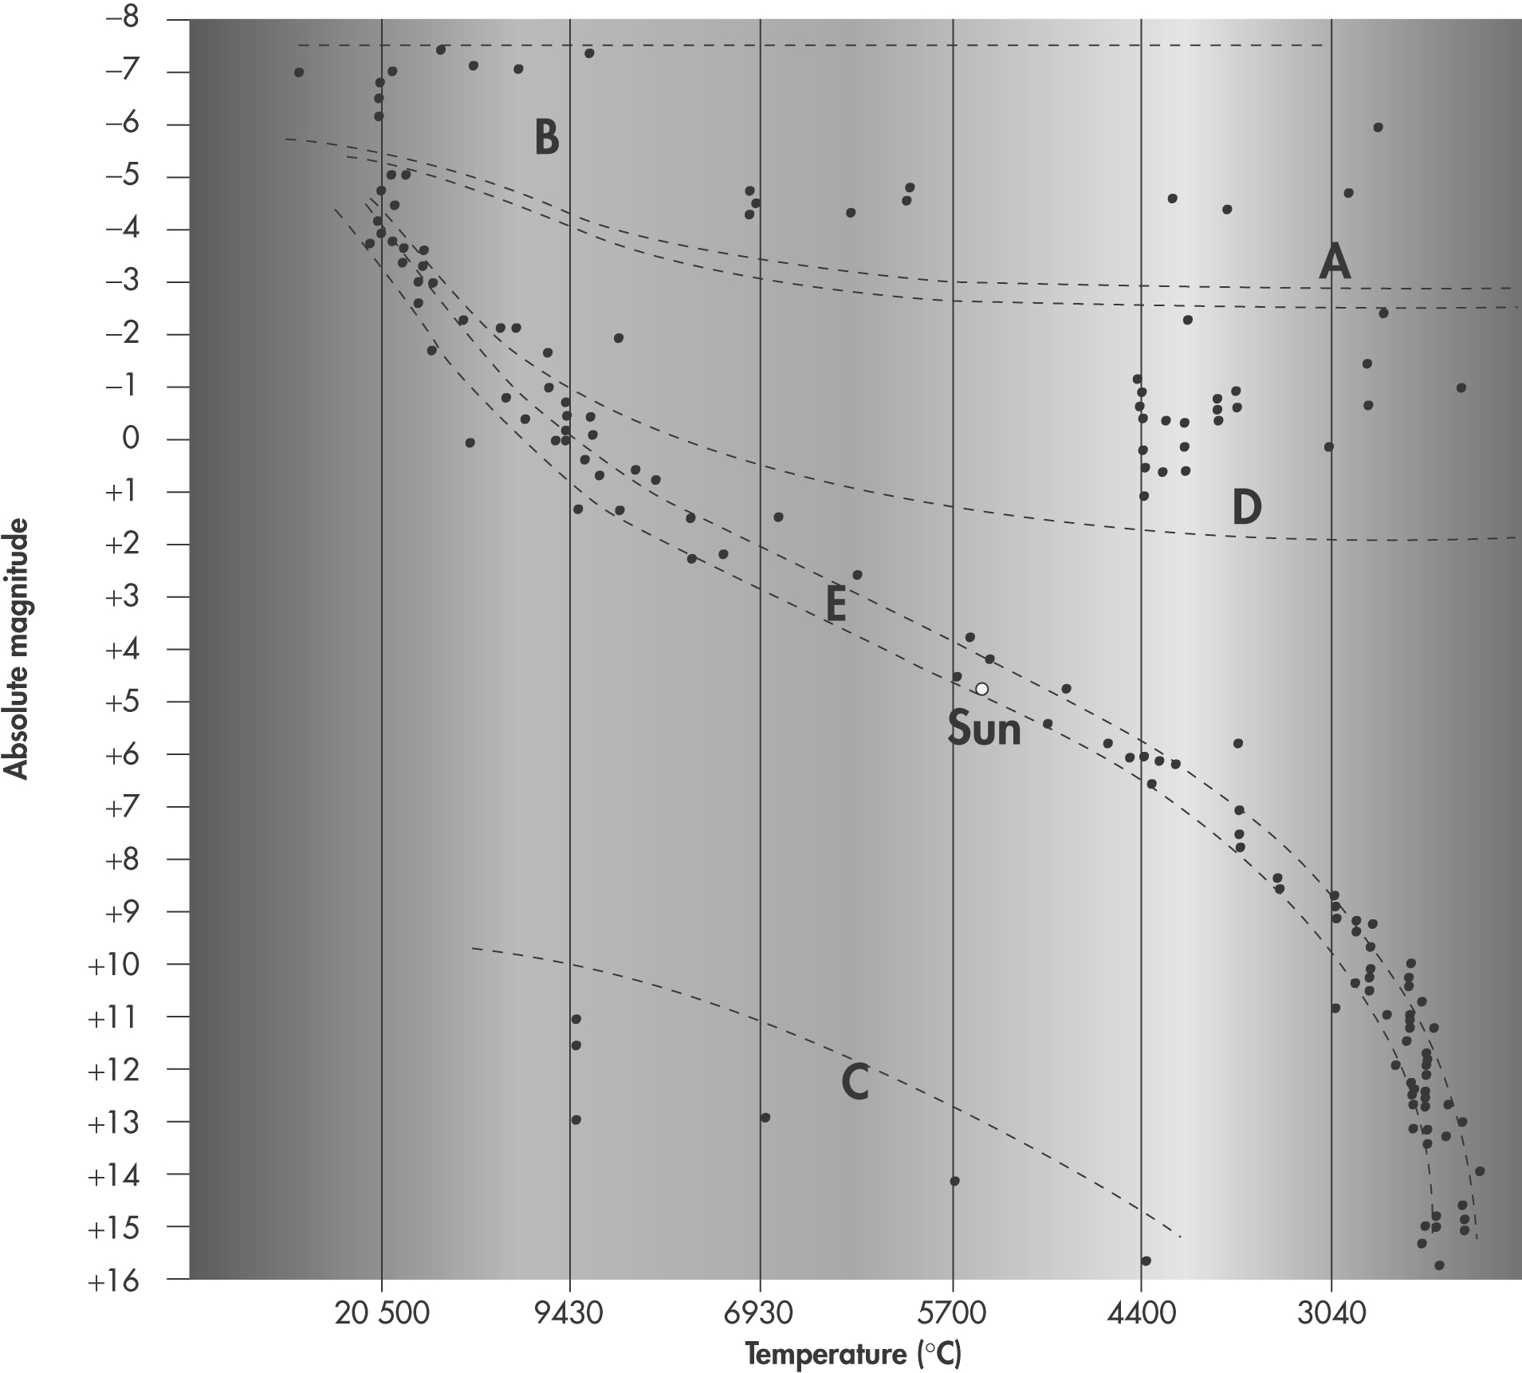

1. Where are the brightest stars located in this graph?

2. Where are the dimmest, coolest stars located in the graph?

3. Identify the type of star represented by the letters:
A:
B:
C:
D:
E:
4. During the next stage in our sun’s life cycle it will move off the main sequence of the graph. Which region of the graph (A–E) will it move to next?

5. Explain how the absolute magnitude of a star is different to its apparent magnitude.

6. A star has an absolute magnitude of –6 and a surface temperature of 2900 °C.
(a) Predict the colour of this star.

(b) Identify the group that this star belongs to.

